Softw Syst Model (2005) 4: 171–188 / Digital Object Identiﬁer (DOI) 10.1007/s10270-005-0079-0

*Expert’s voice*

On the uniﬁcation power of models

Jean B´ezivin

ATLAS Group, (INRIA & LINA) University of Nantes, 2, rue de la Houssini`ere, BP 92208, 44322 Nantes Cedex 3, France e-mail: [Jean.Bezivin@lina.univ-nantes.fr](mailto:Jean.Bezivin@lina.univ-nantes.fr)

Published online: 10 May 2005 –  Springer-Verlag 2005

Abstract. In November 2000, the OMG made public the MDATMinitiative, a particular variant of a new global trend called MDE (Model Driven Engineering). The ba- sic ideas of MDA are germane to many other approaches such as generative programming, domain speciﬁc lan- guages, model-integrated computing, generic model man- agement, software factories, etc. MDA may be deﬁned as the realization of MDE principles around a set of OMG standards like MOF, XMI, OCL, UML, CWM, SPEM, etc. MDE is presently making several promises about the potential beneﬁts that could be reaped from a move from code-centric to model-based practices. When we observe these claims, we may wonder when they may be satisﬁed: on the short, medium or long term or even never per- haps for some of them. This paper tries to propose a vi- sion of the development of MDE based on some lessons learnt in the past 30 years in the development of object technology. The main message is that a basic principle (“*Everything is an object* ”) was most helpful in driving the technology in the direction of simplicity, generality and power of integration. Similarly in MDE, the basic principle that “*Everything is a model* ” has many inter- esting properties, among others the capacity to generate a realistic research agenda. We postulate here that two core relations (*representation* and *conformance*) are as- sociated to this principle, as *inheritance* and *instantia- tion* were associated to the object uniﬁcation principle in the class-based languages of the 80’s. We suggest that this may be most useful in understanding many ques- tions about MDE in general and the MDA approach in particular. We provide some illustrative examples. The personal position taken in this paper would be useful if it

This paper is based on a guest talk presentation given at the UML’2003 conference in San Francisco and entitled: “*MDATM: From Hype to Hope, and Reality*”

http://[www.sciences.univ-nantes.fr/info/perso/permanents/](http://www.sciences.univ-nantes.fr/info/perso/permanents/) bezivin/UML.2003/UML.SF.JB.GT.ppt

could generate a critical debate on the research directions in MDE.

Keywords: MDE – MDA – Models – Metamodels

1. Introduction

There is presently an important paradigm shift in the ﬁeld of software engineering that may have important consequences on the way information systems are built and maintained. Presenting their “*software factor* y” ap- proach, J. Greenﬁeld and K. Short write in [14]:

“The software industry remains reliant on the craftsmanship of skilled individuals engaged in labor intensive manual tasks. However, growing pressure to reduce cost and time to market and to improve software quality may catalyze a tran- sition to more automated methods. We look at how the software industry may be industrialized, and we describe technologies that might be used to support this vision. We suggest that the current software development paradigm, based on object orientation, may have reached the point of exhaus- tion, and we propose a model for its successor.”

The central idea of object composition is progressively being replaced by the notion of model transformation. One can view these in continuity or in rupture. The idea of software systems being composed of interconnected ob- jects is not in opposition with the idea of the software life cycle being viewed as a chain of model transformations.

In this paper we compare the evolution and achieve- ments of object technology in the past period with the new proposals and claims of MDE. The main message is that a basic principle in object technology (“Everything is

an object” [P1]) was most helpful in driving the technol- ogy in the direction of simplicity, generality and power of integration. Similarly in MDE today, the basic principle that “Everything is a model” [P2] has many interesting properties, among others the capacity to generate a re- alistic research agenda, as will be detailed in Sect. 5. We suggest that this may be most useful in understanding many questions about MDE in general and the MDATM approach in particular.

|  |  |
| --- | --- |
| Everything is an object | [P1] |
| Everything is a model | [P2] |

As suggested by Figs. 1 and 2, the core conceptual tools that were in focus in the 80’s are being renewed. At the beginning of object technology, what was import- ant was that an object could be an instance of a class and a class could inherit from another class. This may be seen as a minimal deﬁnition in support of principle [P1]. We call the two basic relations *instanceOf* and *inherits- From*. Very diﬀerently, what seem to be important now is that a particular view (or aspect) of a system can be cap- tured by a model and that each model is written in the language of its metamodel. This may be seen as a mini- mal deﬁnition in support of principle [P2]. We call the two basic relations *representedBy* and *conformsTo*. It is very likely that the discussions on the exact meaning of these two central relations associated to principle [P2] will take some time to settle. Similarly to the sometimes-heated initial discussions on the two relations related to principle [P1] of object-oriented programming, this is also likely to generate many lively debates. The deﬁnitions we propose here are very loose and preliminary, but we are still at the stage of identifying the hard core principles of MDE.

The danger would be to use the old [P1] relations within the new context of MDE, for example by stating

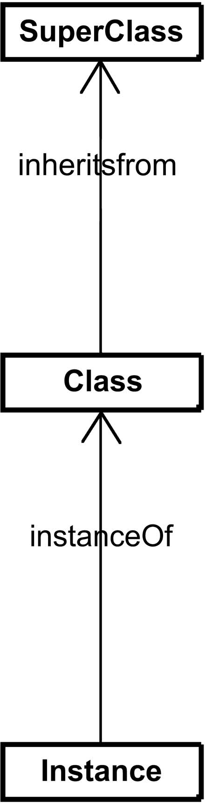

Fig. 1. Basic notions in object technology [P1]

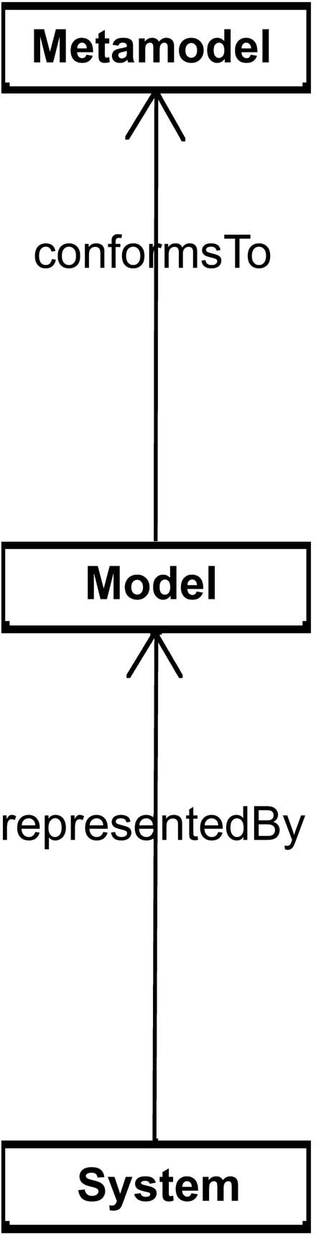

Fig. 2. Basic notions in MDE [P2]

that a model in an *instanceOf* a metamodel1. This point of view often leads to many confusion and does not help in clarifying a complex evolution.

Separate consideration of the set of relations [P1] and [P2] will also help to assess that MDE and the ob- ject technology views of the software development world should not be considered as opposite but as complemen- tary approaches.

The MDE approach has not a unique goal. Among the objectives pursued, one may list the separation from business-neutral descriptions and platform dependent implementations, the identiﬁcation, precise expression, separation and combination of speciﬁc aspects of a sys- tem under development with domain-speciﬁc languages, the establishment of precise relations between these dif- ferent languages in a global framework and in particular the possibility to express operational transformations be- tween them.

Similarly, when object technology was introduced, it had no unique goal. In order to fulﬁll object technology multiple objectives, principle [P1] has been most helpful in the last period but seems now to have reached its limit for the increasingly complex and rapidly evolving systems we are building today. A complete new rise in abstraction seems absolutely necessary. Principle [P2] is a candidate for the paradigm shift corresponding to this important and necessary evolution.

To make this more concrete, let us take as an ex- ample one of the ﬁrst objective of MDA: separating the business part from the platform part of systems in order to independently control their evolution [27]. Applying

1 More generally, there is an over-usage of this *instanceOf* rela- tion in MDE. Used in diﬀerent contexts, with diﬀerent meanings, this may cause additional confusion. Careful distinction between at least three diﬀerent usages of this relation is suggested in [3] and [8].

principle [P1] to this problem yielded the MVC architec- ture where a pure business class (called a *Model* ) relates in a precise standard way with two other classes (called a *View* and a *Controller* ) handling platform-speciﬁc pre- sentation and rendering on one side and device-based dialogue control on the other side. The object technol- ogy abstraction mechanisms have partially contributed to solve the problem (GUI architecture). Unfortunately they fall short in solving it in its entirety (separating business from platform). The hope is to apply principle [P2] to the same problem in a very diﬀerent and more general way: a platform-based transformation could pro- duce an executable system from a business description, bound to this speciﬁc platform, from the neutral de- scription of a business system. The complete feasibility and practicability of this process has still to be demon- strated, but we can nevertheless see how diﬀerently both [P1] and [P2] attack this problem, with diﬀerent levels of ambition.

This paper is organized as follows. In Sect. 2 we look at object technology and how it has achieved progresses through the uniﬁcation principle. In Sect. 3 we discuss one view of the uniﬁcation principle in MDE. In Sect. 4 we review some examples of models for illustrative pur- pose. In Sect. 5 we show how a research agenda for MDE could be inferred from the generalized application of principle [P2].

1. The lessons of object technology

When we look at the two basic relations of Fig. 1, we ﬁnd them to be quite characteristic of object-technology. However this has not always been so clear. In program- ming languages like *ThingLab* [9], a *partOf* explicit rela- tion was also proposed as an integral part of the language. In other object-oriented languages like *Self* , the concept of class itself was absent and thus this language was not based on the set of relations of Fig. 1. In modern lan- guages like *Java*, the additional concept of *Interface* is also part of the scope. There were heated debates in the 80’s about the exact meaning of these relations, including the controversies between single and multiple inheritance. Nevertheless the deﬁnition of class-based program- ming languages like *Java* or *C#* are more or less based on the central organization depicted in Fig. 1, with rather consensual deﬁnitions of this set of relations. What we call an object is an instance of a class, this class possibly

inheriting from another class.

Based on these common assumptions, some languages may go beyond these deﬁnitions, for example by provid- ing more or less general metaclass organization schemes (a class being an instance of a metaclass). As a conse- quence, when we talk about an object, the context is im- portant. In a general context, we usually mean an entity corresponding to the scheme deﬁned in Fig. 1. If we need to be more speciﬁc, we refer to a *C#* object, a *Java* ob-

ject, a *C* ++ object, an *Eiﬀel* object, a *CLOS* object, etc., with usually additional properties.

* 1. *Towards uniﬁcation*

Since the inception of object technology, the uniﬁcation principle has been an engine for progress. The very basic idea of an object in *Simula* was a device that could unify data and process, a signiﬁcant ﬁrst step in achieving prin- ciple [P1]. *Simula* walked an initial path in this direction and its authors may be credited from having proposed the basic scheme of Fig. 1.

After *Simula*, the language that has probably most in- ﬂuenced the development of industrial object technology was *Smalltalk* . This language, through several iterations, going from *Smalltalk-72* to *Smalltalk 80* , tried to push as far as possible this idea that everything is an object in several ways:

* + - Starting from the relations in Fig. 1, the considera- tion of classes as objects directly induced the neces- sity to consider metaclasses as independent entities. Furthermore the consideration of metaclasses as ob- jects made necessary to provide a global and regular scheme for organizing this system where the super- class of a metaclass was identical to the metaclass of the super-class. Other schemes like *CLOS* , *ObjVlisp*, etc. have also been proposed, that tried to push fur- ther this principle that everything is an object.
    - Considering *integer* or *boolean* values as objects was a radical position at the time since it lead to view the expression *i* + *j* as the sending of message + with argu- ment *j* to object *i* and not as the operator + applied to operands *i* and *j*. Of course the concept of prim- itive method allowed dealing with this uniform view without severe performance penalties. The distinction between primitive data types and object-based data types, at the language level, is probably not the best solution and Smalltalk avoided this pitfall by treating this distinction only at the implementation level. To this respect again, Smalltalk was an improvement on most of its successors, to use the famous formulation of

C.A.R. Hoare.

* + - Another step was to consider messages themselves as objects. Here again the language designers managed to provide a uniform view with reasonable implemen- tation overhead by allowing messages to be reiﬁed as true objects when needed, i.e. for example on sending errors. In these cases the *doesNotUnderstand* : method could be used to deal with a real message object, in- stance of the *MessageSend* class.
    - As a last example we may also quote the eﬀorts to deal with methods as objects. The uniﬁcation of block closures and methods was not completely achieved in *Smalltalk-80* , but the fact that block were true ob- jects allowed to investigate a lot of interesting issues, like extensible control structures built up from simple message passing mechanisms.

Many of these advances were unfortunately not selected in modern convergence languages like *Java* or *C#*. How- ever we can see that much progress in object technol- ogy has been made while this [P1] principle was actively pursued.

* 1. *Incomplete achievements*

On the contrary, the recent period of object technology shows many examples of situations where abandoning the quest for this [P1] principle has lead to some diﬃculties or at least some incomplete achievements. We may give some examples.

* + - With procedural technology, the notion of multiple entry point could be used to deﬁne an application as a set of services. This was used in many methods based on stepwise reﬁnement in the 70’s. What mod- ern object-oriented programming languages have been able to oﬀer is that unique entry point philosophy, the “infamous” *public static void main (Strings [] args).* We probably missed one opportunity to represent, at the programming level, an application and its entry points by an object and its methods. In order to com- pensate this drawback on the programming side, I. Jacobson introduced the concept of Use Case in the UML language but this was outside the scope of the programming language itself. The impendence mis- match between these two views may partially explain the success today of service-oriented computing on object-oriented computing.
    - The ﬁrst real life deployment of object-oriented sys- tems showed that the complexity of such systems could not be only encapsulated in the class deﬁn- ition themselves, but in the subtle relations between these classes. The normal reaction was to invent a new language based on design patterns. Unfortunately, here also, the principle of uniﬁcation could not be fully applied. As a consequence design patterns can- not be seen, for the time being, as entities respecting principle [P1].
    - More recently, there was recognition that object- oriented techniques were not suﬃcient to express the various aspects on a system. The Aspect Oriented Programming movement is currently trying to ﬁnd solutions to this problem based on code-centric ap- proaches. The objective of considering aspects as full- ﬂedged objects, respecting principle [P1], has not yet been completely realized.

There are a lot of missed (or at least incompletely matched) opportunities in object-oriented technology [13]. One of the major ones was the rendezvous between ob- jects and the Web (it would have been a nice property if every object could have been identiﬁed by a URI). The marriage of objects and databases has produced limited results, far to corresponding to the initial hopes. In spite of many clever research ideas, the uniﬁcation of objects

and processes is not still achieved on practical basis (e.g. in workﬂow systems). We could also mention the limited contribution to reusability2. The origin of many of these problems may be traced to some form of abandoning the search for uniﬁcation after the Smalltalk period. As a con- sequence, object-oriented computing is no more in a situ- ation to play the role of an integration technology. Instead it is today in the state of a very useful technology to be integrated with other technologies like service-oriented computing and many others.

1. MDE: concepts and goals

As the notion of object was central to the software devel- opment practices of the 80’s, the notion of model seems today to focus much attention. The question of deﬁning what a model is, on a practical basis, will probably take as much time and energy to settle as the deﬁnition of the no- tion of an object. We propose in this paper to start from the two basic relations associated to principle [P2].

* 1. *On the meaning of models*

When we look at the general deﬁnition of a model, we ﬁnd a set of diﬀerent ones, some of them even being contra- dictories. For example, on the ten deﬁnitions given in the Encarta Encyclopedia [11], there are essentially two that corresponds to our purpose in the context of MDE:

“mod·el [m´odd’l] noun (plural mod·els)

1. copy of an object: a copy of an object, espe- cially one made on a smaller scale than the original (*often used before a noun*)

5. simpliﬁed version: a simpliﬁed version of something complex used, for example, to analyze and solve problems or make predictions *a ﬁnancial model* ”

These two meanings roughly correspond to the con- sensual deﬁnition given by J. Rothenberg in [25]:

“Modeling, in the broadest sense, is the cost- eﬀective use of something in place of something else for some cognitive purpose. It allows us to use something that is simpler, safer or cheaper than re- ality instead of reality for some purpose. A model represents reality for the given purpose; the model is an abstraction of reality in the sense that it cannot represent all aspects of reality. This allows us to deal with the world in a simpliﬁed manner, avoiding the complexity, danger and irreversibility of reality.”

2 Object technology promised for example application extensibil- ity through class inheritance. We know today that one important kind of application extensibility is implemented with plugins, as in the Eclipse system for example. This concept of plug-in does not owe much to class inheritance.

The word *model* comes from the Latin *modullus* through the Italian *modello*3 . Initially *modullus* was the diminutive of *modus*, meaning a special constraint ratio, used in architecture, between parts of a building in construction.

Modeling is essential to human activity because every action is preceded by the construction (implicit or ex- plicit) of a model. The medical technique of bloodlet- ting for example was based on an incorrect model of the body4. If the model is incorrect, the action may be inappropriate5.

There are plenty of practical usages of models: sta- tistical model, meteorological model, biological models, ecological models, economical models, etc. Computer sci- ence may be mainly described as the science of building software models. If the use of the word model in engin- eering sciences is quite recent, the idea itself goes back to ages. Plato (427-347 BC) in the Timaeus already used the concept of irrigation channels to describe blood vessels. Later, this same model was “reﬁned” by the English phys- iologist W. Harvey (1578–1657), to characterize the blood circulatory system.

The blood circulatory model is only one view or aspect on the human body among many others (skeleton, mus- cular, digestive, respiratory, endocrinous, nervous, etc.). The human body being the system, a diﬀerent model characterizes each aspect. This is the ﬁrst relation *repre- sentedBy* associated to principle [P2].

There are still a lot of tentatives for building models, for example models of the brain, of the human genome, etc. A process of trial and error usually elaborates models progressively. In human history, models that have con- centrated much energy are geographical models or maps. Even after the roundness of the earth was commonly ac- cepted, it took quite a time to the ﬁrst explorers to pro- gressively assess their maps of the world.

Today we are using a lot of diﬀerent maps. If one wishes to ride a bike or a truck through a given terri- tory, the map used will be diﬀerent. If one wants to visit museums or to rapidly drive on highways in the same area, diﬀerent maps of the same territory will also be use- ful. Map making is usually a human activity. In certain cases automation may help (e.g. satellite photography) and in very speciﬁc situations we can have automatic map production. Similar remarks will apply to automatic model production in the information system area. A map is a representation of a given territory. The ﬁrst relation

3 Another previous import of *modullus* in the Middle Ages also gave the word *mould.*

4 Hyppocrates and many others believed that the four crucial elements earth, air, water and ﬁre were balanced within the hu- man body as the four humors: blood, phlegm, and black and yellow bile. In this context, disease was due to an imbalance in the four humors and treatment involved restoring their balance through bloodletting.

5 Georges Washington died after heavy blood loss sustained in a bloodletting treatment for laryngitis.

(*representedBy*) of principle [P2] clearly appears in these situations.

This example of geographical maps has much inspired the reﬂection on modeling practices. The notion of pre- ciseness of a model for example has progressively been considered as a relative notion. A model is not intended to capture all the aspects of a system, but mainly to abstract out only some of these characteristics. Instead a system is usually represented by a set of diﬀerent models, each one capturing some speciﬁc aspects.

Many authors, from L. Carroll to J.-L. Borges or

U. Eco, have told the same story of people competing to build complete models of a system, for example maps at the 1:1 scale6. For example in “*Mary and Bruno con- cluded* ”, L. Carroll narrates the following story:

“That’s another thing we’ve learned from *your* Na- tion,” said Mein Herr, “map-making. But we’ve carried it much further than you. What do you con- sider the *largest* map that would be really useful?” “About six inches to the mile.”

“Only *six inches!”* exclaimed Mein Herr. “We very soon got to six *yards* to the mile. Then we tried a *hundred* yards to the mile. And then came the grandest idea of all! We actually made a map of the country, on the scale of *a mile to the mile!”*

”Have you used it much?” I enquired.

“It has never been spread out, yet,” said Mein Herr: “the farmers objected: they said it would cover the whole country, and shut out the sunlight! So we now use the country itself, as its own map, andI assure you it does nearly as well.

But there are many other lessons to be learnt from geographical maps as well. If we look at the map pre- sented in Fig. 3, we see in the bottom-left corner some information expressed, as in the remainder of the map, in a graphical form. But the nature of this information is diﬀerent from the one in the remainder of the map. It is a *legend* indicating how to interpret the map itself. A map would be useless without a legend. Loosing the legend and this map would be impossible to interpret. There may also be implicit elements in a map, for example the scale or the direction (the top of the map represents the North direction), etc.

We say that the map conforms to its legend, i.e. that the map is written in the (graphical) language deﬁned by its legend. This immediately generalizes to a model conforming to its metamodel, the second relation (*con- formsTo*) associated with principle [P2].

The relation between a model and its metamodel is also related to the relation between a program and the programming language in which it is written, deﬁned by its grammar, or between an XML document and the deﬁning XML schema or DTD.

6 This story may be usefully recalled when one tries to capture in a UML model the totality of aspects of a Java program.

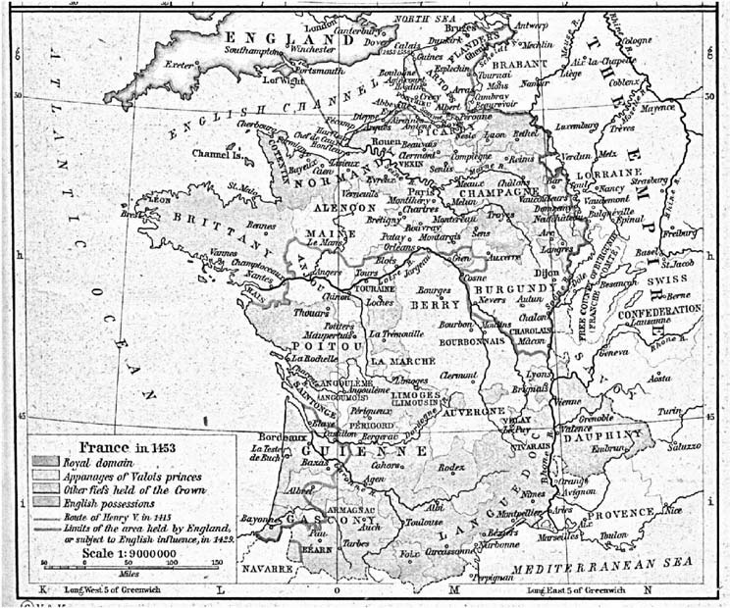

Fig. 3. Map of France in 1453 from the Historical Atlas by R. Shepherd

Similarly to discussions that took place about the dis- tinction between instantiation and inheritance, there may also be discussions on the two relations associated to prin- ciple [P2]. One of them is particularly confusing on the meaning of the expression “*the model of a model* ”. This is usually shorthand for “coercing” the model as a system and extracting another model from it. For example we could have a map of the area of Seattle at scale 1:50 000. Then we could consider this map as a system and derive from it another map at scale 1:100 000. So the normal interpretation of “the model of a model” is more nat- urally related to the *representedBy* relation and not to a metamodel7. To make clearer this distinction, let us look at Fig. 4. This famous painting by R. Magritte reads “*This is not a pipe*” below the picture of a pipe, insist- ing on the fact that the painting of a pipe may be useful for several purposes, but certainly not to smoke tobacco. Similarly we may have a painting of the painting, and so on. This is what we call a model of a model but this is not a metamodel.

Of course this discussion may clarify the ﬁrst relation of [P2] (*representedBy*), but diﬃculties lay also in the deﬁnition of the second relation (*conformsTo*). The na¨ıve

7 Asked about the reason of interpreting “the model of a model is a metamodel”, a student answered that this was because he re- membered that “a class of a class is a metaclass”. This shows again at the same time the danger of approximations, uncontrolled analo- gies and mixing the two systems of relations associated to [P1] and [P2].

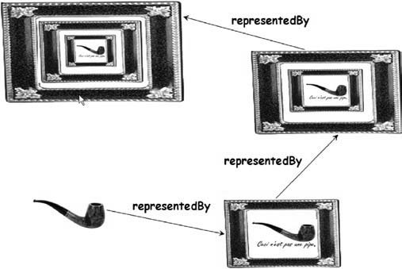

Fig. 4. “Ceci n’est pas une pipe”, painting by Magritte revisited

introduction to these concepts needs to be elaborated on a more precise and formal way. In particular, one dimen- sion that is absent in the previous discussion is the need for coordinating diﬀerent maps. Since we said that we will use diﬀerent maps to express diﬀerent views on a given territory, and since these maps may be jointly used, then we must take some actions to allow the *coordination* be- tween these views. Let us suppose that towns, on diﬀerent maps, are diﬀerently drawn. We would need to assess that these towns correspond to similar entities, enabling them to act as “join points” between diﬀerent views. We may state that each legend deﬁnes some kind of “domain spe-

ciﬁc language”, but how may these languages be related? The limits of the analogy show up here in this case, be- cause what we would need is a language for describing legends, what we shall call a metametamodel.

The postulate of the existence, in each technical space [18], of a unique metametamodel, is essential if we want to compare, transform, merge, make diﬀerences, etc. between diﬀerent models. In MDE this postulate is essential since the number of diﬀerent domain speciﬁc languages is very rapidly growing, with the danger of frag- mentation. In MDA, the unique metametamodel is the MOF (Meta-Object Facility).

* 1. *From contemplative to operational models*

One important diﬀerence between the old modeling prac- tices and modern MDE is that the new vision is not to use models only as simple documentation but as formal input*/*output for computer-based tools implementing precise operations. As a consequence model-engineering frameworks have progressively evolved towards solid pro- posals like the MDA deﬁned by the OMG. We may clearly see the three levels of principles (general MDE princi- ples as described in this paper), of standards (e.g. the OMG*/*MDA set of standards), and of tools (like the EMF, Eclipse Modeling Framework or the Visual Studio Team system).

Progressively we come to understand much better the possibilities and limits of this new way of considering in- formation systems. The notion of a metamodel is strongly related to the notion of ontology. A metamodel is a formal speciﬁcation of an abstraction, usually consensual and normative. From a given system we can extract a particu- lar model with the help of a speciﬁc metamodel. A meta- model acts as a precisely deﬁned ﬁlter expressed in a given formalism.

To make this more concrete, let us take one example. Suppose we want to consider a system *S* composed of sev- eral users accessing a UNIX operating system. We wish to take a model of this (Fig. 5). The ﬁrst step will be to de- ﬁne the aspects which we are interested in, and ignore the aspects we want to discard.

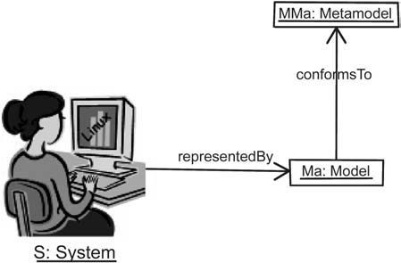

Fig. 5. Extracting a model from a system

We do this with a metamodel *MMa* like the following one:

class(User,Group,File,Directory,FileElement); association(belongsTo,User*,Group) association(owns,User,FileElement*) association(contains,Directory,FileElement*) inherits(File,FileElement); inherits(Directory,FileElement);

This means that we are only interested in *Users*, *Groups* of users and *FileElements* like *Directories* and *Files*. Furthermore, we would like to consider only the facts that a *File* or *Directory* is contained into a *Direc- tory* or is owned by a *User* or that a given *User* belongs to a *Group*. Simple multiplicity indication is provided here by starred names.

Metamodel *MMa*, applied to system *S*, will for ex- ample yield the following *Ma* model:

meta(Bob,User); meta(Jim,User); meta(Esther,User); meta(Mary,User);

meta(Student,Group); meta(Teacher,Group); meta(F1,File); meta(F2,File); meta(F3,File); meta(F4,File); meta(F5,File); meta(D1,Directory); meta(D2,Directory);

meta(D3,Directory); belongsTo(Esther,Teacher);

belongsTo(Mary,Teacher); belongsTo(Jim,Student); belongsTo(Bob,Student); owns(Esther,D1); owns(Esther,F1); owns(Mary,D2); owns(Mary,F2);

owns(Bob,D3); owns(Bob,F3);

owns(Jim,F4); owns(Jim,F5); contains(D1,F1); contains(D2,F2); contains(D3,F3); contains(D2,D3); contains(D1,F4); contains(D2,F5);

This means for example that *User Jim belongs* to the *Student Group* and *owns File F* 4, *contained* in *Direc- tory D*1. The relation *conformsTo (Ma, MMa)* is hold- ing at the global level and summarizes the various *meta (X,Y)* relations between any model element *X* and meta- model element *Y* .

It is worthwhile mentioning how this organization may lead at least to partial automation. One may un- derstand how a UNIX shell script *P* could automatically generate a model similar to *Ma*. This script may be com- posed of classical UNIX commands like *ﬁnd* , *ls*, *grep*, *sed* , *awk* , etc. The interesting question however is how far this script *P* could be derived from the speciﬁcation of metamodel *MMa*. By decorating each metamodel elem- ent of *MMa* with the UNIX code in charge of discover- ing the corresponding element (*Class* or *Association*), we progress towards this goal. Producing a model like *Ma* corresponds then to a graph exploration of metamodel *MMa*, with execution of the associated UNIX discovery code for each visited element.

We have used the textual notation of *sNets* [20] for deﬁning the *MMa* metamodel and the *Ma* metamodel

above. Of course, the same could also be expressed in a more classical way, like a visual UML-like notation, as suggested by Fig. 6. The use of visual notations may be very helpful, but is not one essential basic princi- ples of MDE. The visual expression of a metamodel as presented in Fig. 6 is a convenience. Since deﬁning meta- models is an activity much less frequent than deﬁning models, specialized tools for performing this task are not economically interesting to build. This is why usu- ally one has a tool for building models and will use it, in a special way, to build metamodels. Since the most popular metamodel in the MDA space is UML for the time being, the natural way is to use a UML case tool for building a metamodel. This is made even simpler by the alignment of the MOF (the standard lan- guage to write metamodels) with a limited subset of UML.

The basic use of a metamodel is that it facilitates the separation of concerns. When dealing with a given sys- tem, one may observe and work with diﬀerent models of this same system, each one characterized by a given metamodel. When several models have been extracted from the same system with diﬀerent metamodels, these models remain related and, to some extent, the op- posite operation may apply, namely combination of concerns.

The organization of the classical four-level architec- ture of OMG should more precisely be named a 3+1 ar- chitecture as illustrated in Fig. 7. At the bottom level, the M0 layer is the real system. A model *represents* this sys- tem at level M1. This model *conforms* to its metamodel deﬁned at level M2 and the metamodel itself *conforms* to the metametamodel at level M3. The metametamodel *conforms* to itself. This is very similar to the organiza- tion of programming languages. A self-representation of the EBNF notation takes some lines. This notation allows

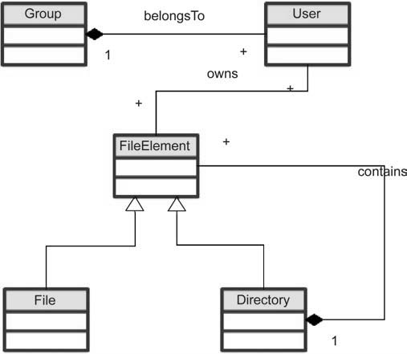

Fig. 6. Another expression for the *MMa* metamodel

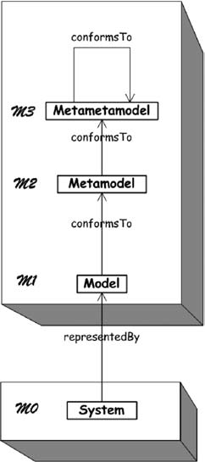

Fig. 7. The 3 + 1 MDA organisation

deﬁning inﬁnity of well-formed grammars. A given gram- mar, for example the grammar of the Pascal language, allows deﬁning the inﬁnity of syntactically correct Pascal programs.

As previously stated, one of the best-known metamod- els in the MDA is the UML metamodel. Many CASE tools have been built to support this graphical language. How- ever the real power of the MDA framework comes from the existence of level M3. This allows building coordi- nation between models, based on diﬀerent metamodels. One example of such coordination is model transform- ation, but there are many others that could be envisioned like model weaving. The existence, in the MDA, of the MOF recommendation [21] at level M3 allows using stan- dardized metamodels (like CWM, SPEM, EDOC, etc.). Furthermore the MOF allows deﬁning bridges between the MDA technical space and other spaces like the XML document space (through the XMI standard [23] for se- rialization) or the Java technical space (through the JMI standard for accessing model elements). Many other stan- dard projections could be useful as well like on mid- dleware spaces (CMI for CORBA Model Interchange). Separation between content and presentation of models may also be achieved by standard projection on render- ing spaces like SVG. So any MDA-model contains in- formation but lacks facilities to handle it. One classical possibility is to use projections to other technical spaces where these facilities are available. If we want to trans- port a model, than we may use the XMI projection on the XML space; if we want ﬁne-grained access to model elements, then we may use the JMI projection on the Java space; if we want to display the model, we may use projec-

tion on SVG space, and so on. Projections are associated to the MOF and may be seen as additional facilities of level M3.

1. On various kinds of models

The impact of MDA on the organization of software pro- duction and maintenance workbenches is beginning to appear. The UML metamodel, which was previously at the center of these workbenches, is now only one meta- model among others. At the same time, we see a number of new tools appearing, like independent transformation engines and frameworks. All these tools operate on top of a model and metamodel repository. Each of them imple- ments a limited set of speciﬁc operations on models and metamodels. Their behavior is sometimes partially driven by generic uploadable metamodels. The MDA landscape is going to be populated by a high number of metamod- els, like the programming language technical space which is populated by a high number of language grammars or the XML document space populated by DTDs and XML schemas. Most tools were ﬁxed metamodels tools (mainly UML-based) and now we see a new generation emerging of variable metamodel tools, these tools themselves be- ing sometimes partially generated from the metamodel deﬁnition.

When principle [P2] is accepted, we will see hundreds or even thousands of metamodels being deﬁned and used. Each metamodel will correspond to a speciﬁc need, goal or situation.

For example some metamodels are object-oriented, some are not. In this section we give some illustrative examples of the great variety of diﬀerent models. An ex- ample of an object-oriented metamodel is given in [6]. Showing a Smalltalk metamodel (at the M2 level), and a Smalltalk program (at the M1 level), this example has the advantage of clarifying the correspondences be-

tween metaprogramming and metamodeling organiza- tions. These are orthogonal dimensions, presented hor- izontally for the Smalltalk metaprogramming approach and vertically for the metamodeling approach. For ex- ample the question “what is *Felix* ?” has two complemen- tary answers: horizontally *Felix* is a *Cat* and vertically *Felix* is a *Smalltalk instance*.

The Smalltalk metamodel presented in Fig. 8 is ob- viously much simpliﬁed and is not the only possible one. Many other diﬀerent aspects of a Smalltalk system could be of interest and captured by diﬀerent metamod- els. For example the following metamodel states that a Smalltalk-80 system is composed of a set of *Cate- gories*, containing each a number of *Classes*, each *Class* containing a number of *Variables* and *Methods* (class or instance variables and methods), the *Methods* being themselves organized in containers called *Protocols*. Fur- thermore a number of global variables (*PoolVariables*) may be associated to several *Classes*. The domain spe- ciﬁc language deﬁned by the metamodel below could be combined with the metamodel provided at level M2 in Fig. 8.

class(Method, Protocol, Class, Category, Body); class(Variable, InstVar, ClassVar, PoolVar); association(methodOf, Method*, Class); association(classes, Class*, Category); association(methods, Method*, Protocol); association(variables, Variable*, Class); association(pools, PoolVar*, Class*); association(body, Method, String); inherits(InstVar, Variable); inherits(ClassVar, Variable); inherits(PoolVar, Variable);

After this presentation of the Smalltalk example, some remarks may complement this view:

* There is no standard view of a given system. The two presented Smalltalk views are only some among

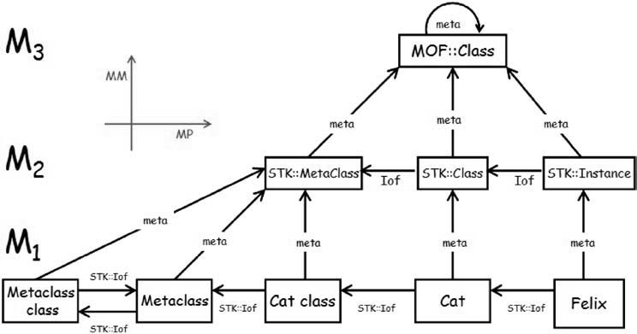

Fig. 8. Metamodelling vs. metaprogramming

many possibilities. For example, another diﬀerent metamodel may contain the concept of *Method* inter- preted not as above as a primitive *String* type, but as a structured organization of syntactic concepts. Any metamodel is associated with an envisioned goal of the extracted model. Also class inheritance relations are not shown in this metamodel to keep things simple, but could easily be added.

* + If we consider the two previously presented Smalltalk views, we may notice that they are nearly disjoint, except from the concept of *Class* (or of *Stk::Class* in Fig. 8) acting as some kind of “joint point” between the two separate aspects. These joint points may be used in a weaving operation between both metamodels.
  + One interesting property of these small granularity metamodels is that they may be used for speciﬁc pur- poses but also they may also be jointly used. More a metamodel is voluminous less are the chances that it could be reused in joint application.
  + It is quite easy to integrate, into the same metamodel, conceptual categories that concern several diﬀerent areas, like the syntactic deﬁnition of a language and the architecture of the programming environment or IDE. An example for Smalltalk with class categories or method protocols has been given.
  + One consideration that could be raised again at this point is about the relation between principles [P1] and [P2]. When we look at Fig. 1 in the light of the illus- tration of Fig. 8, the idea that comes to mind is that object orientation can be captured by a basic meta- model, alongside a set of extensions and adaptations of this metamodel for various other situations. For ex- ample a metamodel for the Java language could be seen as an extension of the metamodel corresponding to Fig. 1.
  + We have chosen to present metamodels of the Small- talk system. Of course we could also have taken other examples like Simula-67, Objective-C, C++, Java, C#, CLOS, etc. If we had taken the Eiﬀel language, then the concept of *Contract* would also have been present. All these considered languages are class-based languages. We could also have built a somewhat diﬀerent metamodel of Self, an object- oriented prototype-based language. Having all these metamodels may serve not only to compare the lan- guages but also to build operational bridges between them.
  + MDA is able to capture object organizations as well as other organizations. This is the source of its inte- gration capacity. For example a metamodel for simple relational database management system, as pictured in Fig. 9 does not correspond to any object-oriented artifact. However this could be most useful for ex- pressing conversion rules between relational and ob- ject oriented organizations.

Some metamodels may be similar to grammars, but generally they are more versatile. The correspondence be- tween these notions is a subject of current work. Besides the fact that a metamodel is usually graph-based and a grammar tree-based, there are several diﬀerences in ap- plication between these notions. Automatic translation tools between diﬀerent technical spaces are being built, encompassing metamodels to*/*from grammars or meta- models to*/*from XML schemas.

A model is a representation of a system. Some sys- tems are static, i.e. they don’t change with time or may be considered as such. The USA census of year 2000 is a model of a system considered as stable on a given time of April 1, 2000 with 281 421 906 people of various name,

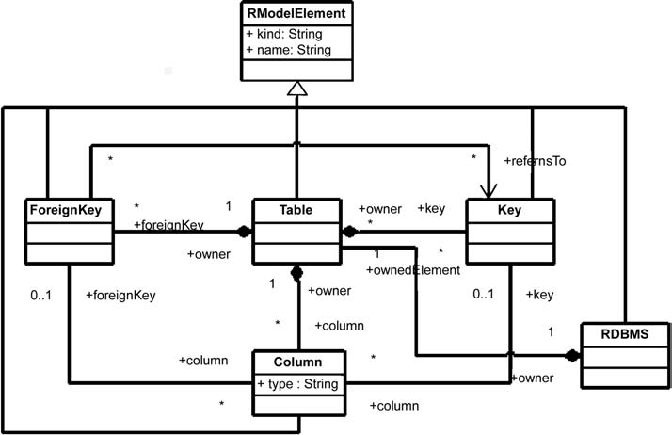

Fig. 9. Example of a relational DBMS metamodel

sex, age, origin and many other characteristics. Obviously the model of a static system is itself static.

On the contrary of this example, most systems are dy- namic, i.e. they change in time. But at the same time most models are static, i.e. they don’t change in time. This is a highly interesting property of models because it facilitates reasoning on these models. A source program is a static model because the code does not change with time8. This characteristic allows for example to establish axiomatic proofs of a program.

A StateChart is a static model of a dynamic system, and many models are of this kind. However, in some cases we may also have dynamic models, i.e. models evolving in time.

Let us take an airport as a system. Let us build a simu- lation of this airport. The airport is represented by the simulation, i.e. the simulation has a behavior that rep- resents the behavior of the real airport. The simulation is a dynamic model. Now if the simulation is written in a given programming language like Simula, the source program of the simulation itself is a static model of the dynamic simulation execution.

Figure 10 summarizes this, by showing that there are static and dynamic systems on one side, static and dy- namic models on the other side. The only combination that seems to make no meaning is a dynamic model of a static system. All other cases make sense, with the most common situation being the case of a static model of a dy- namic system. Whatever the kind of system or model, dynamic or static, we see that the representation relation is deﬁned here by *contextual substitutability*. This means that a model should be able to answer a given set of ques- tions in the same way the system would answer these same questions.

Another important distinction between models is the diﬀerence between product and process models. The re- lation between process and product is a recurrent theme in computer science. Many contributions suggest strong structural correspondence between process and product models, and several authors have provided empirical evi- dence of this in the last decades. These observations were usually made on the occasion of establishing guiding rules

8 Excluding the special case of self-modifying programs

or applied model elaboration. When discussions about Structured Programming were active, N. Wirth noticed that:

“ *...* structuring considerations of program and data are often closely related. Hence, it is only nat- ural to subject also the speciﬁcation of data to a process of stepwise reﬁnement. Moreover, this process is naturally carried out simultaneously with the reﬁnement of the program”.

The relation between process and products take more importance when they are expressed as formal models, within a common framework. One typical example in the MDA area was the decision to separate the search for uniﬁed modeling techniques in two phases. In the ﬁrst one a metamodel for deﬁning software artifacts (UML) was proposed, i.e. a software product metamodel. After that, a second metamodel for expressing software pro- cesses could be designed (SPEM). There are several rela- tions between these two coordinated standards (UML 2.0 and SPEM 2.0).

There are many other situations where a product*/*pro- cess couple exists in the MDE landscape, for example when considering component*/*workﬂow systems. The product metamodel has a role similar to data struc- ture deﬁnition while the process metamodel is more related to generic deﬁnition of control structures. The area of intermodel relationship (similarly to XLink and related facilities in the XML technical space) has how- ever yet to mature. This may be viewed as a special case of establishing global relations between models and metamodels.

Another possible direction is between prescriptive and descriptive models [24]. A descriptive model is a represen- tation of a system already existing. A prescriptive model is a representation of a system intended to be built. As a matter of fact, there is little diﬀerence between these two kinds of models. In the ﬁrst case, a model is built by observation of a system while in the second case a system is built by observation of a model. What is diﬀerent is how these models are used. In the ﬁrst case the model may be used to understand a system or to extract some aspects of this system that could be useful to build another sys- tem later. In the second case, the model may be used as

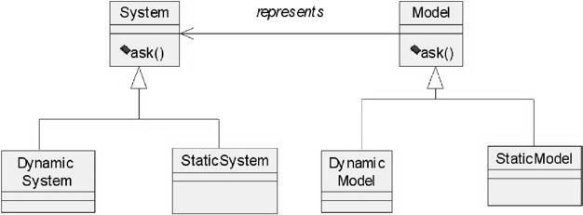

Fig. 10. Relation between static and dynamic models and systems

a guide, a blueprint for building a new system. In both cases the same *representedBy* relation holds at the end.

The classiﬁcation of all these metamodels is a sub- ject of high interest. The variety of diﬀerent metamodels also suggests a secondary specialization relation between metamodels that could be added to complete principle [P2]. There is no yet consensus on this relation that could be used to build a lattice of metamodels, with a top element (the metamodel selecting nothing) and a bottom element (the metamodel selecting all).

Of course the ambition here is completely diﬀerent from general purpose ontology initiatives like Worldnet or Cyc. The applicability domain is limited by the perimeter of information systems building and maintenance and not general knowledge management.

It is likely that large monolithic metamodels like UML

2.0 will see some limitations to their usage because of their complexities. There are several reasons for this. The major one is that most usages rely only on a small sub- set of the entire metamodel. Any well designed process should provide a precise characterization of these sub- sets. Although there are some conceptual tools to do this (UML proﬁles are one example), it is much more diﬃ- cult to work by restriction than by extension. Working by extension means dealing with a much more important number of metamodels of high abstraction. Tools to deal with this important number of combinable and extensible metamodels are still to be invented. Present navigator ar- chitectures, often based on the class browsers of the 80’s, are not suﬃcient to handle this new situation. We need some support for “modeling in the large”, i.e. establishing and using global relations between models, metamodels and the associated metadata.

In this rapid evolution of the industrial landscape, we clearly see the impact of principle [P2] at work. One may not accept to have only, for example, one standard UML to Java transformation option, “hardwired” in a given UML CASE tool. On the contrary, one will use this UML tool to capture UML models, and then choose among a large library of transformations, the ones that would suit its own goal and environment. If none is found, one may specialize some of them to correspond to particu- lar needs. Besides transformation tools, there will also be veriﬁcation, metrication, legacy recovery, model weav- ing tools and much more. All these tools will uniformly access models, metamodels, and their elements through a common standard repository API. This regular indus- trial organization of the tool cooperation, in the software production chain, is made possible because of the uniﬁca- tion power of models.

1. A proposed research agenda

The MDA has demonstrated the realism of MDE prin- ciples. From there on, we may now envision a path of increasing applicability. Several potential progresses may

be associated to the experimental application of princi- ple [P2]. Many open research problems may be related to a loose or strict application of this principle. There is also a need for a deeper understanding of the two associated basic relations.

* 1. *Applying the uniﬁcation principle*

As announced in the introduction, it is our claim that the more we stick to the basic [P2] principle, the more we may hope to see a very general, sound, regular, long-lasting and widely applicable set of techniques. Many of the ex- amples given below suggest research paths that could be investigated in the near future.

*Programs as models.* Programs are expressed in a pro- gramming language. If we make explicit the correspon- dence between a grammar and a metamodel, programs may be converted into equivalent MDA-models. In the same way a Java program may be converted into an XML- model, i.e. into an XML document conformant to the *JavaML* DTD [1] for example. The problem is thus to be able to implement agile bridging between these dif- ferent spaces (MDA, XML and Program space). This is a matter of changing the representation, knowing that each technical space has some advantages and drawbacks. For example the programming technical space illustrated in the left of Fig. 11 has the advantage of granting nat- ural executability, the MDA and XML technical spaces on the other side having the advantage of allowing easier interoperation with other speciﬁc standards and tools.

*Traces as models.* A program may also be considered as a static system because its code does not change with time. Another interesting system is one particular execu- tion of a program, which is a dynamic system. As previ- ously discussed, we can have models of dynamic as well as static systems. One example of a model of the dynamic execution of a program is a trace. A trace is an interesting example of a model. It may be based on a metamodel and will express the speciﬁc events traced (object creation, process activations, method calls, exception events, etc.).

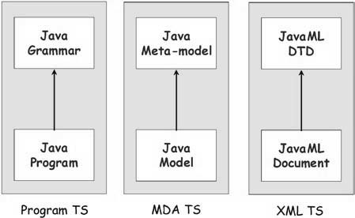

Fig. 11. The same program represented in diﬀerent technical spaces

*Platforms as models.* In the traditional MDA approach, the objective is to be able to generate platform spe- ciﬁc models (PSMs) from platform independent models (PIMs). In order to carry this task with suﬃcient au- tomacity we need to have precise models of the targeted platforms like the *Web*, *CORBA*, *DotNet* , *EJB* , etc. Plat- form description models (PDMs) seem presently to be the missing link of the MDA. Answering the question of what is a platform may be diﬃcult, but until a precise answer is given to this question, the notion of platform depen- dence and independence (PSMs and PIMs) may stand more in the marketing than in the technical and scientiﬁc vocabulary.

There is a considerable work to be done to character- ize a platform. How is this related to a virtual machine (e.g. JVM) or to a speciﬁc language (e.g. Java)? How is this related to a general implementation framework (e.g. DotNet or EJB) or even to a class library? How to cap- ture the notion of abstraction between two platforms, one built on top of the other one? The notion of a platform is relative because, for example, to the platform builder, the platform will look like a business model. One may also consider that there are diﬀerent degrees of platform in- dependence, but here again no precise characterization of this may be seriously established before we have an initial deﬁnition of the concept of platform.

One possible hint to answering this question would be to use insight from the work of M. Jackson [16]. As sug- gested by Fig. 12, the idea of considering on one side the world, on the other side the machine and to interpret the intersection as shared phenomenon, bear some similari- ties with the classical “*Y* development cycle”, revisited in MDA style. The lowest part of Fig. 12 suggests that the production of a PSM may be more a model weaving than a direct model transformation operation.

*Legacy as models.* There is more than forward engin- eering in MDE. Platform of the past (*Cobol* , *PL/1* ,

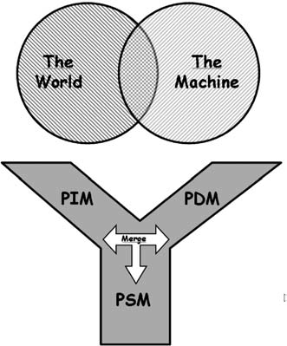

Fig. 12. The world and the machine

*Pascal* , *CICS* , etc.) should be considered as well as platforms of the present or platforms of the future. The extraction of MDE-models from legacy systems is more diﬃcult but looks as one of the great chal- lenges of the future. There is much more to legacy ex- traction than just conversion from old programming languages.

*Model elements as models.* In many cases we have the situation where we need models with elements represent- ing other models or metamodels, for example to describe the software assets of a company. Of course each such element has a “type” corresponding to its own meta- model. Model and metamodel portfolio management is a subject of high practical interest that has still to be con- ceptually investigated.

*Transformations as models.* As a special example of the search for uniformity, let us look more in detail at the example of transformations as models [4]. We shall elabo- rate more on this to illustrate our main point. As in other technical spaces, the MDA realized there was a need for some kind of uniﬁed transformation language or at least a family of such languages. One idea initially suggested by R. Lemesle [20] was to extend the metametamodel (MOF) with basic transformation facilities. Another idea proposed later was to deﬁne transformations DSLs, lead- ing to the *MOF/QVT* request for proposal [22]. This latter approach will allow dealing with several diﬀerent transformation languages in the MDA space, or at least with a family of transformation languages.

A transformation generates a target model *Mb* from a source model *Ma* (Fig. 13). Applying principle [P2], the transformation *Mt* itself should be a model. From that point, there are several conclusions that could be drawn. Some of them are being more important than others:

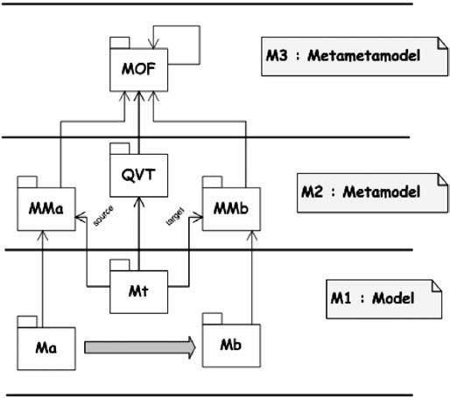

Fig. 13. Model transformation

* Since often models may have a visual presentation, this can provide a natural way to graphically depict transformations.
* A model conforms to a metamodel. The source and target models conform to metamodels *MMa* and *MMb*. Similarly the transformation *Mt* : *Ma->Mb* (i.e. the transformation program itself) conforms to a metamodel *MMt* deﬁning the common model trans- formation language*.*
* One nice consequence of this regular organization is that we may envision the possibility of higher-level transformations, i.e. transformations taking other transformations as input and*/*or producing trans- formations as output.
* This regular organization does not bear an import- ant implementation overhead. As a matter of fact, the transformation engine is installed on a model and metamodel repository, uniformly considering the six input, output and transformation models and meta- models (*Ma*, *Mb*, *Mt* , *MMa*, *MMb* and *MMt* ).
* When we say that the result of a transformation is to generate a model *Mb* from a model *Ma*, we have a bit oversimpliﬁed the situation. As a matter of fact we also need to generate a traceability model *Mtr* that could be used with the target model *Mb* for various reasons. Obviously this traceability model also con- forms to a speciﬁc metamodel. There are several pos- sible traceability metamodels.

Perhaps the domain of model transformation is the one that is presently the most illustrative of the bene- ﬁts that could be reaped from a general application of principle [P2]. In our ﬁrst experiments with the ATL lan- guage [7], some of these advantages have been noticed. In this ATL project, a transformation virtual machine has been deﬁned with a set of bytecode operations accessing the model and metamodel elements, providing indepen- dence from the underlying layer (*EMF* , *MDR*, etc.). The idea that a common language could be used for any kind of input or output metamodels is now established. The fact that all input, output and traceability models and metamodels are similarly considered, allows basing the transformation virtual machines on a very well deﬁned API for accessing to the various elements of these models and metamodels.

*Metamodels as models.* There is no reason that we could not apply transformations to metamodels themselves as we apply them to models. It is even possible to consider special operations taking a model as input and promot- ing it as a metamodel. One example of such a tool is the *UML2MOF* component available in the *MDR/NetBeans* space but this may also be considered as standard model transformation operations, expressed for example in lan- guages like ATL.

an improvement or veriﬁcation could be viewed as regular operations on models. Veriﬁcation for example could take a model and a set of veriﬁcation rules as its input.

*Components as models.* Since there are so many diﬀerent kinds of models, we need to consider them as uniformly as possible for several operations like storage, retrieval, etc. This has given rise to this idea of general model components [5]. This notion of model component is dif- ferent from the classical notion of “objects components”, a` la EJB for example. The notion of MDA component is related to issues of packaging, typing, naming, referenc- ing, etc.

This list is obviously very incomplete. When we con- sider MDE with this uniﬁed vision, many well-known situations may be integrated into a more general consid- eration. To take one additional example, the seminal work of R. Floyd (“*Assigning meanings to programs*”, [12]) that founded the research ﬁeld of programming axiomat- ics may be viewed as “decorating” a ﬂowchart model with an axioms model. This may lead us ﬁrst to consider decorations9 as models, then to understand the nature of the binding between the ﬂowchart model and the axioms model, this binding being itself some kind of correspon- dence model. Finally, these considerations may lead us to generalize R. Floyd’s approach and to add on the research agenda a new item on “Assigning meaning to models”. Model weaving and model transformation will be essen- tial to the study of this subject.

* 1. *Some open research issues in MDE*

Besides the previous open problems directly derived from the basic uniﬁcation principle, some additional investiga- tions will be also quite important in the ﬁeld. Most of them seek to achieve a better understanding of the two [P2] relations and their possible extensions.

Regarding the correspondence between system elem- ents and model elements, we have yet a lot of progresses to make in understanding the representation relation be- tween a system and a model. If we have a discrete system composed of system elements, then the model represented as a set of model elements may be considered as a sub- set of the ﬁrst one. But this probably does not capture all the aspects of the reality like the class as the set of its in- stances does not capture the totality of the meaning of the *instanceOf* relation.

One troubling issue in a theory of modeling is that a same thing may be considered at diﬀerent points in time as a system or as a model. For example an abacus may be considered as a physical system made of beams, beads and roads but at the same time it may be a model of the business system and transactions for a shopkeeper in Asia. There are several theories proposing an interpre- tation of this situation. One of them is related to semi- otics [28]. In Fig. 14, a cat is represented by a symbol

*Veriﬁcation as models.* Many operations on models may

be seen as special cases of transformations. A refactoring, 9 Some also talk about techniques for “marking” models.

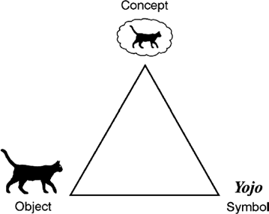

Fig. 14. The Sowa meaning triangle

in the Sowa meaning triangle, like a purchased article price may be represented by a set of beads in a Chinese abacus.

Another possible interpretation could be to consider an explicit “casting” conversion for considering a model as a system. We mentioned this earlier when talking about deriving a 1:100 000 map from a 1:50 000 map. This explicit *asSystem* operation, applied to model *M* , would allow to extract again a new model *M* t from model *M* . In current practice this is a frequently observed opera- tion. The question again is how to relate this “*model of a model* ” relation with a normal model transformation operation.

When the meaning of the two basic [P2] relations will have been settled, then additional secondary relations may be considered to extend the scope of this principle [P2]. The ﬁrst candidate, mentioned already from place to place in this paper, would be an *extension* relation be- tween metamodels. For the time being, the ad-hoc mech- anism of *proﬁles* has been used to this purpose, but it probably brings more problems than solutions. Several important questions should be answered before a pre- cise metamodel extension mechanism could be deﬁned and this device should have very well speciﬁed proper- ties. A metamodel should be able to extend one or more other metamodels by adding new elements. The extension mechanism should be completely deﬁned at level M3 (i.e. at the metametamodel level) in order to be truly meta- model agnostic. The added elements should be related to elements in the base metamodel or to other added elem- ents by a precisely deﬁned relation. We have yet to see a complete proposal for a general, precisely deﬁned meta- model extension mechanism; this issue is high in priority position in the list of model engineering issues to solve.

As already mentioned, the solutions to many problems need a prior deﬁnition of the exact status of the rela- tions between elements of diﬀerent metamodels (global inter-model relations), between elements of a same meta- model (intra-model relations) and between a model and elements of a model. The same also applies to relations between diﬀerent metamodels or even relations between models and metamodels.

Many operations, of diﬀerent arities, on models and metamodels have yet to be identiﬁed [5]. Model trans- formation is only one of them. Among important other operations that need to be speciﬁed, one may quote for example model weaving, model merging, model diﬀer- ence (*diﬀ* on models), model metrication (establishing measures on models), metamodel alignment, etc. General operations may be applied to most models but speciﬁc operations may be applied to speciﬁc kinds of models only. One example of a general operation that could be applied to any kind of model is the serialization pro- jection (in XMI format for example). One example of an operation that could only be applied to a transform- ation model is preliminary veriﬁcation with respect to a couple of metamodels (source and target). Such a pre- liminary veriﬁcation of a transformation model could be checked before applying this transformation to a spe- ciﬁc model. The notion of operation signature in terms of the involved metamodels has been proposed in [5]. Strict deﬁnition of these model operation signatures may help to precisely identify the functionalities of var- ious MDE tools like CASE tools and to separate au- tomatic operations (e.g. transformations) from manual ones (e.g. model capture, model browsing, etc.). This no- tion of model operation signatures hands itself easily to transformation into a system of model-based Web ser- vices going as far as service discovery in a general MDE platform.

Similarly to normalization properties that were de- ﬁned on RDBMS, suitable properties could be associated to metamodels. Perhaps the best starting point to deﬁne this would be the proposals made in ontology engineering by N. Guarino [15]. More generally, many known results and operations in ontology engineering may be of high rel- evance to model engineering as well.

Another set of issues are related to the evolution (ver- sioning) of metamodels. This is not something new but results previously obtained in other domains would have to be adapted to MDE. It is unlikely that this problem may be conﬁned to the deﬁnition and implementation of model and metamodel repositories. Revisiting the issues of model management in the context of changing meta- models is an important practical issue.

The MDE perimeter is constantly broadening. Behind each ﬁle format, each Visio stencil, each tool API or pro- prietary data format, etc. there are metamodels hiding that could be usefully exposed and made explicit. MDE is not only directed towards code generation, but may also be used to facilitate bridging between diﬀerent tools. By basing this “bridge engineering” on a higher abstract level than simple XML exchanges (by the way of metamodels), it may become possible to achieve an important gain in interoperability.

There are even more speculative uses of MDE in fu- ture information systems. Since each model brings with it its metamodel, automatic application adaptation will be made possible, opening the way for plug-and-play model

adaptation. A typical application may also be built on some code stub and an associated metamodel stub. Ex- tensibility of this application may be obtained with an extension of the stub metamodel. For example it could be possible to deliver such application extensibility with

{*p, x*} pairs where *p* is a plugin (in the sense of an Eclipse plugin) and *x* is the corresponding extension to the stub metamodel.

* 1. *Applications, consequences and perspectives*

When looking at several remarks that have been proposed in this section, a normal reaction is to say that these are in no way innovative because they correspond to old recognized practices. This is absolutely true. The appli- cability of MDE very often meets implicit good practices that have previously been applied by skilled personnel in speciﬁc areas. The contribution of MDE is twofold. First it may broaden the applicability scope by bring- ing the beneﬁts of this recognized know-how to a larger community, mainly through partial automation. Second it improves the good practices by making them explicit, allowing a better understanding and generalization of this know-how.

One frequent objection to MDE is that this approach is related to CASE and metaCASE tools that were pro- posed in the 80’s and that were not able to prove their wide applicability at the time. Why would a similar ap- proach work today if it has not been able to become main-stream earlier? Better technological support for vi- sual systems is not a satisfactory answer even if this may help. A much stronger argument is that model uniﬁca- tion is going to bring through principle [P2] a completely new way to deal with the architecture of such tools and frameworks.

The subject of model uniﬁcation does not only con- cern the strict boundaries of software engineering. Pre- senting the generic model management approach in the database ﬁeld, P. Bernstein states in [2]:

“By model we mean a complex structure that represents a design artifact, such as a relational schema, object-oriented interface, UML model, XML DTD, web-site schema, semantic network, complex document, or software conﬁguration. Many uses of models involve managing changes in models and transformations of data from one model into another. These uses require an explicit representation of mappings between models. We propose to make database systems easier to use for these applications by making model and model mapping ﬁrst-class objects with special operations that simplify their use. We call this capacity model management.”

What has been said of MDE in this section may apply to many other technical spaces as well [18]. As suggested by Fig. 11 for example, a source program written in the

Java language could be called a Java-model and an XML document could be called an XML-model. Preﬁxing the word model by the technical space to which it pertains is more than a convenience notation. Usually a technical space is based on a uniform representation system (trees, graphs, hypergraphs, or other algebraic structures.) that could be described by a metametamodel and related fa- cilities. The XML space is based on trees, but these trees have properties diﬀerent from syntax-oriented trees. An XML document may be well formed (i.e. compatible with the XML metametamodel, but also valid with respect to a particular DTD. This is similar to a model being well formed (with respect to the MOF) or valid with respect to a particular metamodel (e.g. to the UML metamodel). Looking at the similar architecture of various technical spaces may show synergies between these (for example Grammarware [17] or semantic Web) and even opera- tional bridges allowing to convert an *α*-model into a *β*- model, *α* and *β* being diﬀerent technical spaces.

1. Conclusions

Object technology was invented in 1965 in a lab of the University of Oslo. Even if the industry waited more than ﬁfteen years to adopt this practice as mainstream, we have now got a long observation period that may allow us to draw some conclusions from the past, that may help us also understanding more precisely the present and imag- ine the future. The main opinion presented here is that object technology made progresses as long as it tried to follow the basic uniﬁcation principle stating “Everything is an object” and stopped progressing when this basic principle was more or less forgotten. From a very diﬀerent point of view, the same pattern seems to be occurring to- day in MDE. We express the idea that the new uniﬁcation principle that “Everything is a model” may be a strong principle to follow today if we want such initiatives as MDA to become successful in the coming years.

Considering everything as a model in a software de- velopment approach has many consequences that we are progressively discovering. This paper has probably shown only some of them. Besides the advantages of concep- tual simplicity, this also leads to clear architecture, ef- ﬁcient implementation, high scalability and good ﬂexi- bility. Many current projects of implementation of open MDE platforms are starting to demonstrate this on prac- tical grounds.

Since computer science mainly deal with the build- ing of executable models, there is an urgent need to un- derstand exactly which systems theses models represent,

i.e. to have a clear deﬁnition of the *representedBy* rela- tion. The second question is about which language we are going to use to build these models, Java or UML or other alternatives? This second question relates to the under- standing of the *conformsTo* relation. These two relations are not independent since we represent a system by using

a language compliant to a given metamodel. The meta- model provides the concepts and relations that will be used to ﬁlter the relevant entities of a given system in order to extract the model.

In [19], P. Ladkin quotes B. Cantwell Smith [10] as stating:

“What about the [relationship between model and real-world]? The answer, and one of the main points I hope you will take away from this discus- sion, is that, at this point in intellectual history, we have no theory of this [...] relationship.”

Computer science until now has mainly focused on the building of special kinds of models (mainly executable models written in programming languages). It may be time to extend the variety of languages we are using for building software models and to understand more pre- cisely what are the exact sources of the models we are building. MDE being based on the two relations of con- formance and representation may be viewed as taking its inspiration both from language engineering (for the ﬁrst relation of *conformance*) and from ontology engineering (for the second relation of *representation* ).

*Acknowledgements.* I would like to thank the members of the CNRS MDE/AS group and of Dagstuhl seminar #04101 for par- ticipating in various discussions on the topics discussed here. The responsibility for how their suggestions were interpreted (or mis- interpreted) in this version remains, of course, entirely mine. I also want to specially thank William Cook, Jean-Marie Favre, Jean-Marc J´ez´equel, Fr´ed´eric Jouault, Joaquin Miller and Bernard Rumpe for many clarifying discussions on these subjects. Many other people have been inﬂuential in the last years on the ideas pre- sented here, as Steve Cook, David Frankell, Stuart Kent, Shridhar Iyengar, and many others too numerous to be named here. Finally I also acknowledge the inﬂuence on the ideas presented here of many authors of similar studies and particularly Dave Thomas [29] and Ed Seidewitz [26]. Part of the present work has been funded by the European Commission under the “Information Society Technolo- gies” Sixth Framework Programme (2002–2006) by the Modelware project FP6-IP 511731.

References

1. Badros GJ (2000) JavaML An XML-Based Source Code rep- resentation for Java Programs. http://[www.cs.washington.edu/homes/gjb/JavaML/](http://www.cs.washington.edu/homes/gjb/JavaML/)
2. Bernstein PA, Levy AL, Pottinger RA (2000) A Vision for Management of Complex Systems, MSR-TR-2000-53. ftp://ftp.research.microsoft.com/pub/tr/tr-2000-53.pdf
3. B´ezivin J, Lemesle R (2000) Some Initial Considerations on the Layered Organization of Metamodels. In: SCI 2000/ISAS 2000, International Conference on Information Systems, An- alysis and Synthesis, vol IX, Orlando, August 2000
4. B´ezivin J (2001) From Object-Composition to Model-Trans- formation with the MDA. TOOLS-USA’2001, Santa Barbara, USA
5. B´ezivin J, G´erard S, Muller PA, Rioux L (2003) MDA Compo- nents: Challenges and Opportunities. Metamodelling for MDA Workshop, York, 2003
6. B´ezivin J, Gerb´e O (2001) Towards a Precise Deﬁnition of the OMG/MDA(TM) Framework. ASE’01, Automated Software Engineering, San Diego, USA, November 26–29, 2001
7. B´ezivin J, Jouault F, Valduriez P (2005) The ATLAS Model Management Architecture and ATL papers. http://[www.sciences.univ-nantes.fr/lina/atl/](http://www.sciences.univ-nantes.fr/lina/atl/)
8. B´ezivin J, Lemesle R (1997) Ontology-based Layered Semantics for Precise OA&D Modeling. In: ECOOP’97 Workshop on Pre- cise Semantics for Object-Oriented Modeling Techniques, pp 31–37. http://[www.db.informatik.uni-bremen.de/umlbib/](http://www.db.informatik.uni-bremen.de/umlbib/) conf/ECOOP97PSMT.html
9. Borning A (1979) ThingLab – A Constraint-Oriented Simula- tion Laboratory. Ph.D. dissertation, Dep. Computer Science, Stanford Univ., Stanford, Calif., March 1979 (revised version available as Rep. SSL-79-3, Xerox PARC, Palo Alto, Calif., July 1979)
10. Cantwell Smith B (1985) Limits of Correctness in Comput- ers. Report CSLI-85-36, Center for the Study of Language and Information, Stanford University, California, October 1985, pp 275–293
11. Encarta MSDN Encyclopedia (2005)

http://encarta.msn.com/

1. Floyd RW (1967) Assigning Meaning to Programs. In: Proc. Symposium on Applied Mathematics, Vol. 1, pp. 19–32. Amer- ican Mathematical Society
2. Gabriel G (2002) Objects Have Failed OOPSLA’02 debate. Seattle, Washington. http://[www.dreamsongs.com/NewFiles/](http://www.dreamsongs.com/NewFiles/) ObjectsHaveFailed.pdf
3. Greenﬁeld J, Short K (2003) Software factories Assembling Applications with Patterns, Models, Frameworks and Tools. In: OOPSLA’03, Anaheim, CA, Companion Volume, pp 16–27
4. Guarino N, Welty C (2000) Towards a Methodology for Ontology-based MDE. In: B´ezivin J, Ernst J (eds) First In- ternational Workshop on MDE, Nice, France, June 13, 2000. Available from http://[www.metamodel.com/IWME00/](http://www.metamodel.com/IWME00/)
5. Jackson M (1995) The World and the Machine; a Keynote Ad- dress at ICSE-17. In: Proceedings of ICSE-17, ACM Press, 1995
6. Klint P, L¨ammel R, Verhoef C (2003) Towards an engineering discipline for grammarware. Working draft paper July 2003. http://[www.cs.vu.nl/grammarware/](http://www.cs.vu.nl/grammarware/)
7. Kurtev I, B´ezivin J, Aksit M (2002) Technical Spaces: An Ini- tial Appraisal. In: CoopIS, DOA’2002 Federated Conferences, Industrial track, Irvine
8. Ladkin P (1996) On needing models. Universit¨at Bielefeld, 22/02/96. http://[www.rvs.uni-bielefeld.de/publications/](http://www.rvs.uni-bielefeld.de/publications/)
9. Lemesle R (1998) Transformation rules based on meta- modeling. In: EDOC’98, San Diego, 3–5 November 1998. http://[www.sciences.univ-nantes.fr/lina/atl/](http://www.sciences.univ-nantes.fr/lina/atl/) publications/
10. Object Management Group OMG/MOF Meta Object Facility (MOF) Speciﬁcation, September 1997. http://[www.omg.org/docs/ad/97-08-14.pdf](http://www.omg.org/docs/ad/97-08-14.pdf)
11. Object Management Group OMG/RFP/QVT MOF 2.0 Query/Views/Transformations RFP, October 2002. http://[www.omg.org/docs/ad/02-04-10.pdf](http://www.omg.org/docs/ad/02-04-10.pdf)
12. Object Management Group XML Model Interchange (XMI), October 1998. http://[www.omg.org/docs/ad/98-10-05.pdf](http://www.omg.org/docs/ad/98-10-05.pdf)
13. Rothenberg J (1990) Prototyping as Modeling: What is Being Modeled? Rand Note N-3191-DARPA, July 1990
14. Rothenberg J (1989) The Nature of Modeling. In: William LE, Loparo KA, Nelson NR (eds) Artiﬁcial Intelligence, Simula- tion, and Modeling. John Wiley and Sons, Inc., New York, pp 75–92
15. Seidewitz E (2003) What models mean. IEEE Software 20(5):26–32, September/October 2003
16. Soley R, the OMG staﬀ (2000) Model-Driven Architecture. November 2000.

ftp://ftp.omg.org/pub/docs/omg/00-11-05.pdf

1. Sowa J (2000) Ontology, Metadata, and Semiotics. In: ICCS’2000, Darmstadt, Germany, August 14, 2000. Pub- lished in: Ganter B, Mineau GW (eds) Conceptual Struc- tures: Logical, Linguistic, and Computational Issues. Lec- ture Notes in AI #1867. Springer-Verlag, Berlin, pp 55–81.

http://[www.bestweb.net/](http://www.bestweb.net/)∼sowa/peirce/ontometa.htm

1. Thomas D (2004) MDA: Revenge of the Modelers or UML Utopia. IEEE Software, May 2004

Jean B´ezivin is professor of Computer Science at the University of Nantes, France, member of the ATLAS

research group recently created in Nantes (INRIA & LINA-CNRS) by P. Valduriez. He has been very ac- tive in Europe in the Object-Oriented community, start- ing the ECOOP series of conference (with P. Cointe), the TOOLS series of conferences (with B. Meyer), the OCM meetings (with S. Caussarieu and Y. Gallison) and more recently the UML/MoDELS series of con-

ferences (with P.-A. Muller). He also organized several workshops at OOPSLA like in 1995 on “Use Case Tech- nology”, in 1998 on “MDE with CDIF”, at ECOOP in 2000 on “MDE”, etc. His present research interests include model engineering, legacy reverse engineering, and more especially model-transformation languages and frameworks.